Code:
#include <stdio.h>
#include <pthread.h>
#include <semaphore.h>
#include <unistd.h>
#define BUFFER_SIZE 5
int buffer[BUFFER_SIZE];
int in = 0; // Producer index
int out = 0; // Consumer index
sem_t empty; // Counts empty slots
sem_t full; // Counts full slots
pthread_mutex_t mutex;
void* producer(void* arg) {
int id = (int)arg;
for(int i = 0; i < 3; i++) { // Each producer makes 3 items
int item = id * 100 + i;
// TODO: Wait for empty slot
sem_wait(&empty);
// TODO: Lock the buffer
pthread_mutex_lock(&mutex);
// Add item to buffer
buffer[in] = item;
printf("Producer %d produced item %d at position %d\n",
id, item, in);
in = (in + 1) % BUFFER_SIZE;
// TODO: Unlock the buffer
pthread_mutex_unlock(&mutex);
// TODO: Signal that buffer has a full slot
sem_post(&full);
sleep(1);
}
return NULL;
}
void* consumer(void* arg) {
int id = (int)arg;
for(int i = 0; i < 3; i++) {
// TODO: Students complete this similar to producer
sem_wait(&full);
pthread_mutex_lock(&mutex);
int item = buffer[out];
printf("Consumer %d consumed item %d from position %d\n",
id, item, out);
out = (out + 1) % BUFFER_SIZE;
pthread_mutex_unlock(&mutex);
sem_post(&empty);
sleep(2); // Consumers are slower
}
return NULL;
}
int main() {
pthread_t prod[2], cons[2];
int ids[2] = {1, 2};
// Initialize semaphores
sem_init(&empty, 0, BUFFER_SIZE); // All slots empty initially
sem_init(&full, 0, 0);
pthread_mutex_init(&mutex, NULL);
// No slots full initially
// Create producers and consumers
for(int i = 0; i < 2; i++) {
pthread_create(&prod[i], NULL, producer, &ids[i]);
pthread_create(&cons[i], NULL, consumer, &ids[i]);
}
// Wait for completion
for(int i = 0; i < 2; i++) {
pthread_join(prod[i], NULL);
pthread_join(cons[i], NULL);
}
// Cleanup
sem_destroy(&empty);
sem_destroy(&full);
pthread_mutex_destroy(&mutex);
return 0;
}

Output:
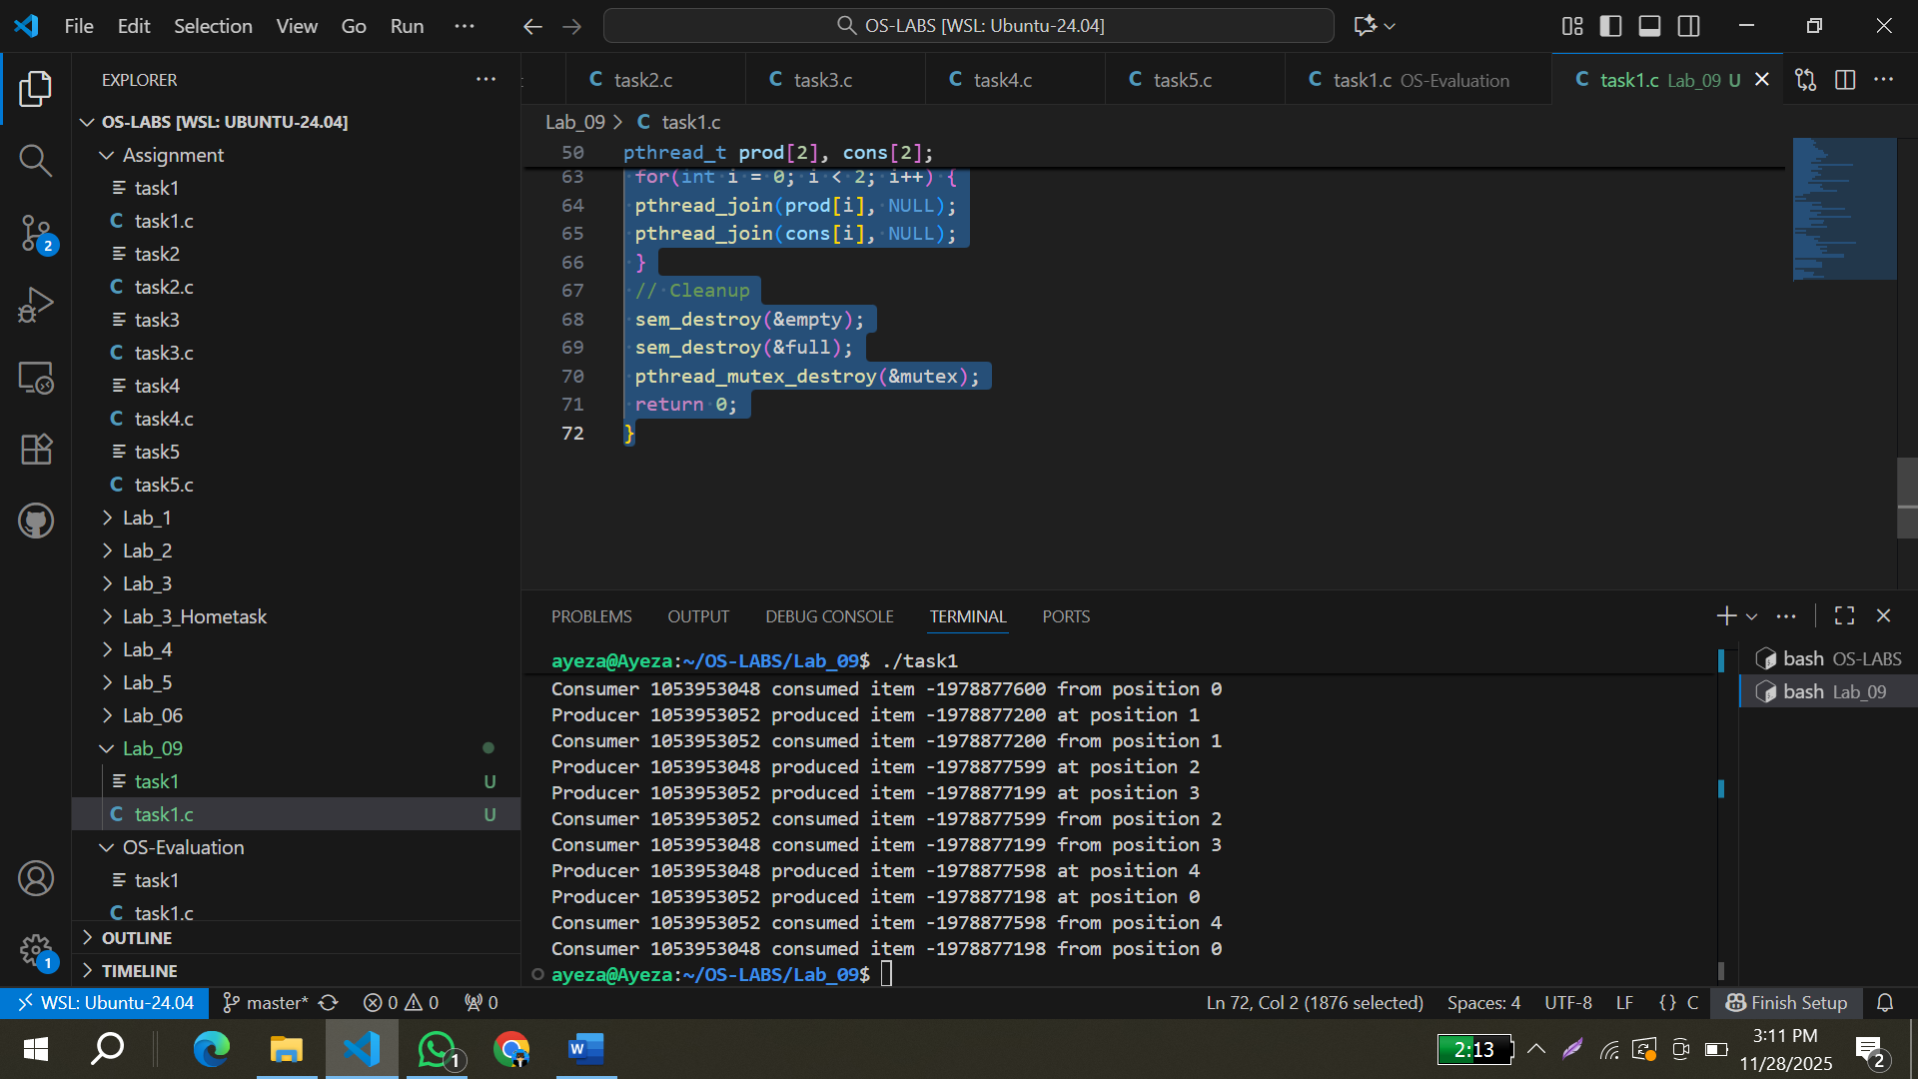
Remarks:
This code implements the producer-consumer problem using thread, a shared buffer with size 5. It uses two producers and two consumers each produce 3 items and each consumer consumes 3 items. It uses two semaphores and mutex for synchronization. In producers, semaphore _ empty waits and semaphore _full posts. In consumers, semaphore _ empty posts and semaphore _full waits.
The semaphores checks that producer don’t add items in full buffer and don’t consume items from empty buffer. Mutex makes sure only one thread uses the buffer at one time.

